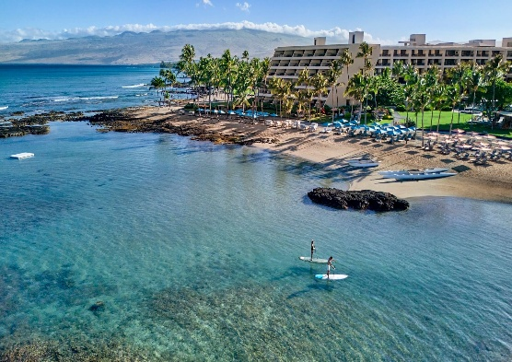
2025 West Coast Brush Manufacturers Association
The Mauna Lani, Auberge Resorts Collection
October 19, 2025 – October 23, 2025
Hotel Reservation Form

Guests Names: ________________________________________________

Address: ________________________________ _________________ ______ _______
Street address City State Zip

Email: ________________________________________

Phone: __________________________

Arrival Date: __________________________

Departure Date: __________________________

Bed type (king or 2 queens): ___________________

Credit Card: The hotel will send you a secure link for your credit card information.

Reservations can be made until August 15, 2025, by calling the Resort’s room reservations department at (877) 804-5736 or by sending requests via email to mnl.groups@aubergeresorts.com and referencing the West Coast Brush Manufacturers Association. If you reserve by email, please use this room reservation form to provide the data that they have requested. A two-night deposit is required at the time of reservation, and is fully refundable by August 15, 2025.

